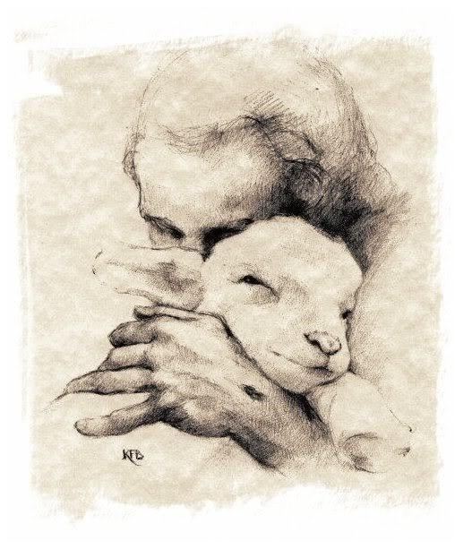

Don’t you just want to go up and give a sheep a big cuddle….The cheeky little face and the fluffy wool….

OK, it is at this point that I am thankful that I can’t see your faces….
But sheep have been an important part of our landscape for many years….and sheep play a prominent part in many a bible story. There are sheep at the birth of Jesus, and sheep play a part in all our readings this morning.
I love sheep so much, that when I had the opportunity to visit a farm just before this lockdown, I jumped at the chance. Driving up the farm track I could see Swaledale sheep….hundreds of them….all gathered in a field by the farm buildings…..the noise was deafening even from the road.
As I continued to drive up the track, I could hear the…newly washed car…being splatted with mud and muck….
Not fazed by this….I jumped out of the car and walked purposely over to the two farmers who ..at that moment… where busy pushing individual sheep into the sheep dip tank….for those of you who don’t know what that is….picture an outdoor concrete bath….filled not with warm soapy bubble bath….but filled with a cold very smelly chemical bath which kills bacteria and helps to keep the sheep healthy….
In my eagerness to see what was happening, I clearly missed a command to stay back…..well, if you have ever seen a dog shaking itself when wet….picture a sheep with more power and much more water….……Yes I was covered in sheep dip…thankfully my coat took a great deal of the liquid, but…shall we say….my beard in never likely to be infected with ANY bacteria.

It’s a messy job farming….and shepherding is both messy and hard work….its not for the faint hearted either…..you have to select sheep, lambs that you have known from birth…to be sent for slaughter….I don’t envy them that task.

Today is the festival of Christ the King….So sheep farming isn’t something that you think of when you think of Kings….Well I don’t….When I think of Kings, I think of opulent palaces, servants, lots of money and power…..the ability to command armies and an expectation that the king WILL be obeyed….or else.

Kings and kingdoms…
A recurring theme in Scripture and in the parables of Jesus.

We all know what kings are – don't we?

Well, Maybe not….
Throughout my lifetime coins and stamps have borne a woman's image…. I have always sung God save the Queen…Never God save the King.

To many in today’s society…me included, the monarchy IS the Queen!! And however powerful some perceive her role to be….she is essentially a powerless figurehead….this is utterly unlike that which we would have encountered at the time of Christ….

The figure of King in the days of Jesus would have been an all-powerful male monarch…..a god like figure who’s power and reach would be almost infinite…..what the king commanded….you and I would have obeyed…..or else….

So, it’s interesting to me to learn that in ancient Israel, the language of sheep and shepherd was often applied to kingship…

Ezekiel underlines this as he proclaims God's promise to search for the wounded and the straggler – as much as to judge between sheep and sheep.
You see, even as they set out to follow the shepherd, some sheep just don't care whom they hurt in their search for good pasture...and then the shepherd changes from gentle leader to agent of justice and judgement.
Perhaps that sounds a bit more like what we expect from a king...The kings of days gone by….riding on horseback into battle…..slaughtering and being slaughtered……sending men to their death.

One image that we see time and again in the portraits of our kings is the ‘Regal Pose’…..You know the pose….There is something about it that makes you know…without words….that this person is a King…or at the least someone very important…..and yes, that king is present at the start of today’s new testament reading…..it says:

When the Son of Man comes in his glory, and all the angels with him, then he will sit on the throne of his glory. This is the court of judgement ...the place where we will hear our own final destiny...truly a place of awe…or maybe a place of fear and uncertainty.

If we want to live in the kingdom, then Christ the king is the one who sets the standards.
Christ, who chooses to spend his time with the marginalised, the oppressed, the forgotten.
Christ who is totally committed to those whom nobody values, nobody respects,
Christ who identifies himself so completely with “the least of these” that when we look at them, we know we are seeing him too.
The hungry, the thirsty, the stranger, the naked, the sick, the prisoner.

These are the People who NEED us, not just a generalised expression of good will...(I’m Praying for you!)
People we probably won't be at ease with,
People we might not like…..it is these we are called to love.
It is in the faces of these People we should expect to see the face of Christ.

To love our King is to love what he has made...children, men and women, joyous, broken, hopeful or despairing...
To love our neighbours is to love the One in whose image they, we, are made...and to recognise the divine image not on stamps or coins but in their faces, wherever we encounter them.

Saint John penned a letter to ‘believers’, such as you and I. He said, ‘No one has ever seen God, but if we love one another, God lives in us and his love is made complete in us.’
We at St. Mary’s Church strive to be a People and a Place where Love works…..and its messy….just as the shepherd and his sheep…maybe not in the same smelly damp way as the sheep dip tank…..but sometimes we have to take that leap….jump in head first and pray that we will surface…..opening our eyes to see the light…..clean and ready to face the world…...it’s still hard work…..but as we look for Christ among those whom we encounter and the experiences that shape us….our challenge is to consider how we can BE Christ...

The Lord your god said: I myself will search for my sheep and will seek them out. As shepherds seek out their flocks when they are among their scattered sheep, so I will seek out my sheep. I will rescue them from all the places to which they have been scattered on a day of clouds and thick darkness.

As I witnessed the Shepherds in Richmond and the love of their sheep, so do we hear of God’s love for his flock….for you and I…You see, there is, in essence, just one commandment, the commandment of love, and real love is no clearer than when shown through actions. And, when it comes down to it, it is living lives of love that will build the kingdom of God here on earth.

Thankfully, We aren't asked to decide who might be sheep or goats...all we are asked to do is to carry on loving…loving extravagantly…wildly….and most importantly…loving indiscriminately…..Christ our King Loves you and I…..and for that I thank God!!!

I pray that the God of our Lord Jesus Christ, the Father of glory, may give you a spirit of wisdom and revelation as you come to know him, so that, with the eyes of your heart enlightened, you may know what is the hope to which he has called you… Amen

